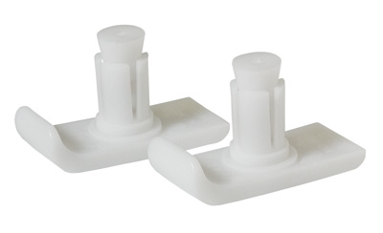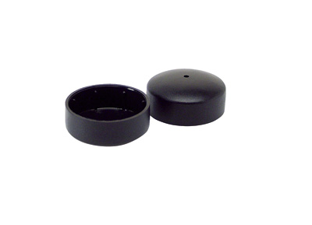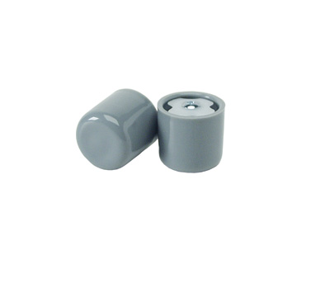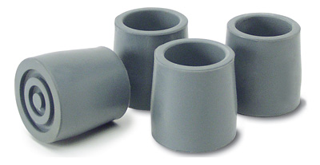
1
2
3
4
1) Walker Ski Glides
Item#63210
Product Detail
Allows walker to slide easily over most surfaces.
Replaces standard walker tips.

2) Walker Glide Caps
Item# 3197
Product Detail
• Allow walker to slide easily over most surfaces.
• Fit over existing rubber tips.

3) Walker Glide Tips
Item# 9138
Product Detail
• Allows walker to slide easily over most surfaces.
• Replaces standard walker tips.

4) Walker Replacement Tips

Item# lx9141
Product Detail
Fits most walker legs made of 1 ¹/8” diameter aluminum tubing.

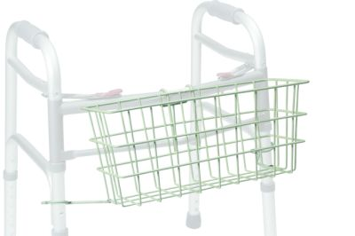

5) Walker Basket
Item# 603904A

Product Detail
Provide a convenient storage area for quick access to personal items

For use with 1” walkers

