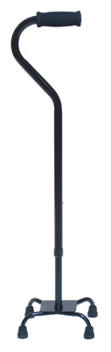 6127A

Quadcane Small Base
Item# 6127A
Product Detail
- Offset handle places the user’s weight over the base for maximum balance and control.
- Low profile, 4-point base further enhances stability.
- Rounded edge base plate helps prevent scraping and bruising of ankles.
- Attractive black finish resists marring and scratching.
- Easy push-button height adjustment with locking collet for added security.
- Height adjusts from 30" to 39" in 1" increments.
- Tool-free left to right hand adjustment is made easily.
- Steel base is strong and durable.
- Nitrile handgrip.
- Includes laminated color operating instructions.
- 300 lb maximum weight capacity.
- Designed to meet the requirements of HCPCS code: E0105.

