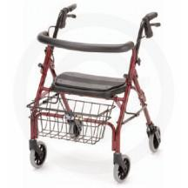
Nova Cruiser Deluxe JR (4207)
Weight Capacity: 275lb
Approx. Patient Height: 4’11-5’3
Product Weight: 14.5 lb

The New and Improved CRUISER DELUXE JR. has a lower handle adjustment (30.5") and seat height (19") then the CRUISER DELUXE. This versatile lightweight walker comes with our patented “Feather Touch” hand braking system, 6" tires, contoured removable back, wider seat with built in seat pad and anatomical hand grips. It is easy to lift and comes standard with the new “Lock N Load” which holds the walker in the folded position for easy loading and un-loading. The Cruiser Deluxe is perfect for indoor and outdoor use. (basket included)

Nova Cruiser Deluxe (4202)
Approx. Patient Height: 5’4-6’0
Product Weight: 16.5 lb

The New and Improved CRUISER DELUXE is the best value in lightweight rolling walkers. This versatile lightweight walker comes with our patented “Feather Touch” hand braking system, large 8" tires, contoured removable back, wider seat with built in seat pad and anatomical hand grips. It is easy to lift and comes standard with the new “Lock N Load” which holds the walker in the folded position for easy loading and un-loading. The Cruiser Deluxe is perfect for indoor and outdoor use. (basket included)

