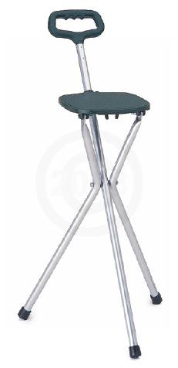

Nova Cane with Seat

Lightweight aluminum construction. A comfortable seat and sturdy cane that is ideal for shoppers, strollers or golfers.

- Weight – 2lbs.
- Tip size – 30010
- Weight capacity – 175lb.
- Seat size – 8"d x 8"w

