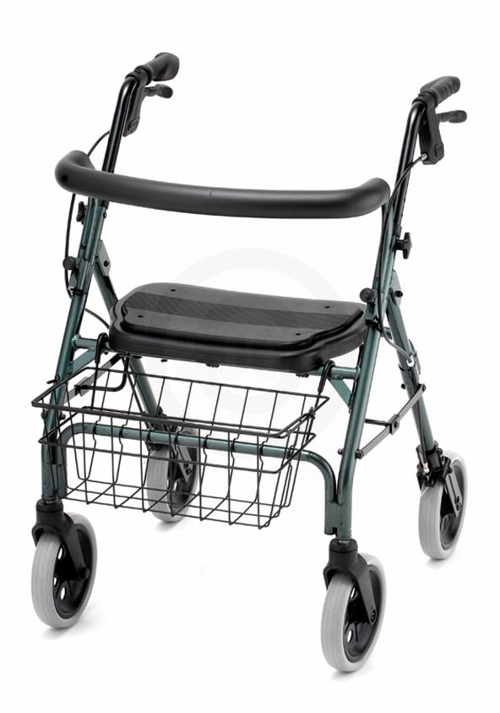

The CRUISER DELUXE is the best value in lightweight rolling walkers. This versatile lightweight walker comes with our patented “Feather Touch” hand braking system, large 8" tires, contoured removable back, wider seat with built in seat pad and anatomical hand grips. The Cruiser Deluxe is perfect for indoor and outdoor use. (basket included)

4202 CRUISER DELUXE
Weight capacity | 300lb.
Weight | 16.5lb.
Handle height | 32"- 36"
Seat dimensions | 17" x 12.5"
Seat height | 20.5"
Width between handles | 19"
Overall dimensions | 23"w x 28"d
Color | blue, red, green, black, purple, silver
Approximate patient height | 5'4" - 6'0"
Overall dimensions folded | 33"l x 23"w x 8"d
Basket dimensions | 16" x 7" x 7"
Optional accessories | tray, basket cover bag, hanging walker bag, cup holder,travel bag

