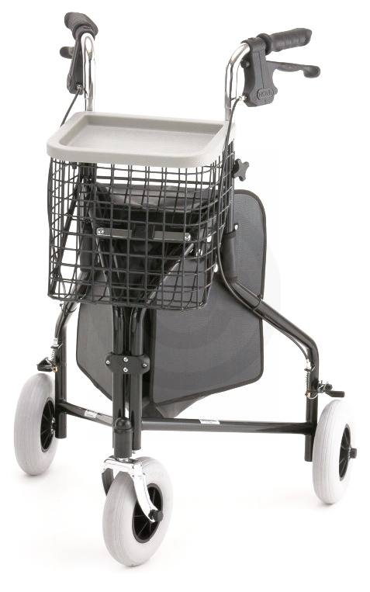

The “TRAVELER” is a light and maneuverable 3-wheeled walker. The solid 8" tires will never puncture and provide a smooth ride on any terrain. Great for the person who does not require the stability of a 4-wheeled walker. (basket, tray and pouch included)

4900 TRAVELER
Weight capacity | 250lb.
Weight | 13lb.
Handle adjustment | 31.5"- 35.5"
Overall dimensions | 26"w x 22"d
Color | blue, red, black
Approximate patient height | 5'0" - 5'6"
Overall dimensions folded | 30"h x 10"w x 24"d
Basket dimensions | 10"w x 9"l x 10"d
Optional accessories | travel walker bag, cup holder

