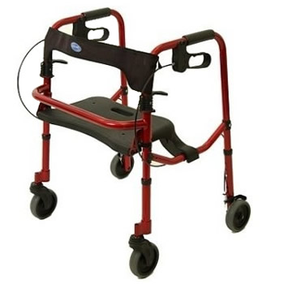

The Invacare Rollite Rollator Jr 65100JR is a cross between a traditional walker and a rollator. The lightweight frame makes it easy to use and carry. The flip-up seat with a built-in handle allows the user to step inside the frame, providing greater reaching access and security for things left in the users basket. The dual paddle folding mechanism and handbrakes enable easy folding and braking. Adjustable seat to floor height provides proper fit and comfort. Invacare has taken the Rollite one step further, offering a new line, For petite user, Lower seat and handle adjustments.
Specifications:
Model Number: | 65100JR
Approximate Patient Height: | 4'10" - 5'6"
Weight Capacity: | 300 lbs.
Weight: | 13.5 lbs.
Handle Adjustment: | 29" - 33"
Overall Width: | 27"
Colors: | Blue, Red
Overall Depth: | Folded: 7", Open: 24"
Width Between Handles: | 18.25"
Seat Height: | 16.5" - 20.5"
Seat Size: | 17"(w) X 9.5"(D)
Wheels: | 5" solid

