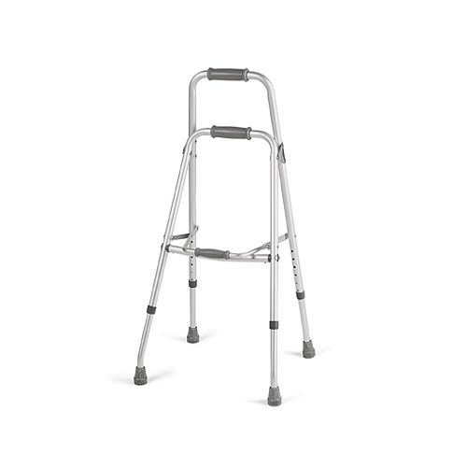
The Adult Hemi Walker is designed for patients with limited or no dexterity in one arm or hand. This lightweight walker combines support and stability, yet is easy to lift and maneuver, even with one hand.
Features
- Wider base provides more stability than a quad cane; Lightweight and maneuverable
- Compact size for easy storage and transport
- No assembly required- Anodized aluminum tubing
- Two-level, comfortable handgrips provide support for standing from a seated position
- Extra handgrip provides ease in folding; Slip-resistant rubber tips
Specifications
- Patient Height: 5'1" - 5'10"
- Product Weight: 2 lb 14 oz
- Product Weight Capacity: 250 lb

