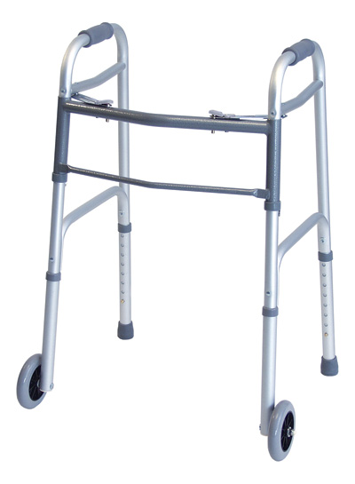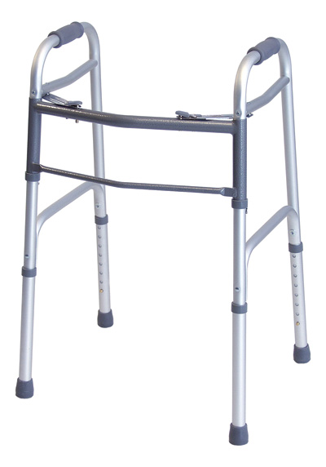
Front Wheel Walker /Junior or Adult

Height: Junior 4’7- 5’3 Adult 5’4- 6’2

Product Detail

• 5" front fixed wheels.
• Rear glide caps to facilitate use on all surfaces.
• Sturdy 1" aluminum tubing provides maximum strength while remaining lightweight.
• Dual-release folding mechanism enables user to fold walker sides independently.
• Designed to meet the requirements of HCPCS code: E0143.
• 1 year limited warranty.

StockCode - Description | Width Inside Handgrips | Width Inside Rear Legs | Overall Width | Depth Front to Rear | Minimum Height | Maximum Height | Weight Capacity
716370A - Junior | 16.5" | 19" | 19 ½" | 15" | 27 ½" | 34 ¼" | 300 lb

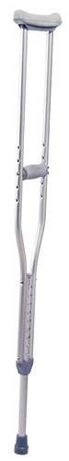 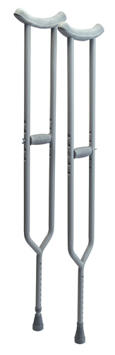3614A Bariatric
Product Detail: Crutches
Youth 4’6-5’2 Adult 5’2–5’10 Tall 5’10-6’6

• Made of lightweight, anodized aluminum.
• Reinforced center tube and footpiece provide added strength.
• Push button adjustment makes changing height easy.
• Height adjustment in 1" increments.
• Handgrip position is readily adjusted with wing nuts.
• Underarm and handgrip pads are comfortable and durable.
• Includes laminated color operating instructions.
• 300 lb maximum weight capacity.
• Designed to meet the requirements of HCPCS code: E0114.
• Limited lifetime warranty.

Bariatric Crutches Item# 3614A
• 600 lb maximum weight capacity.
• Heavy duty steel construction.
• Push button height adjustment makes changing height easy.
• Height adjustment in 1" increments.
• Handgrip position is readily adjusted with wing nuts.
• Underarm and handgrip pads are comfortable and durable.
• Designed to meet the requirements of HCPCS code: E0114.

