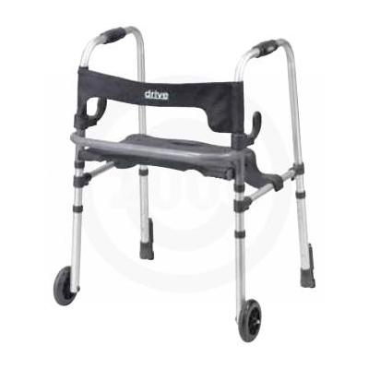

Clever-Lite LS Walker w/ Seat

- Push down brakes.
- Comes with flip up seat with built in carry handle.
- Allows individual to be seated or raised to step inside the frame.
- Easily folds with dual clever side paddle release.
- Soft, flexible backrest provides comfort and security while seated.
- 5" fixed front wheels.
- Rear glide brakes.
- Sturdy 1" diameter anodized, extruded, aluminum construction.
- Capacity 300Lbs
- Patient Height 5’1 – 6’2
- Product Weight 8 lbs

