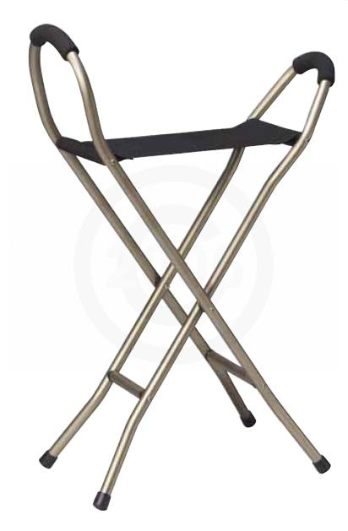

- Provides a comfortable seat to rest on when open, and a sturdy quad cane when closed.
- Strong aluminum bronze construction.
- Four sturdy legs with vinyl contoured tips.
- Nylon sling bench, 18" x 8".
- Foam grip handles.
- 34" tall when closed.
- Seat to floor height: 22"
- Weighs 2.4 lbs.
- 250 lb. Weight Capacity.
- Limited Lifetime Warranty on frame, 6 Month Warranty on Sling.

