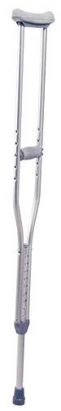 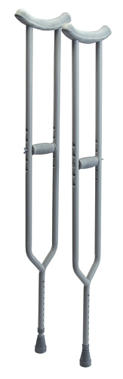3614A Bariatric (600Lb Cap)

Crutches
Product Detail

Youth 4’6-5’2 * Adult 5’2–5’10 * Tall 5’10-6’6 * 250 Lb Cap

• Made of lightweight, anodized aluminum.
• Reinforced center tube and footpiece provide added strength.
• Push button adjustment makes changing height easy.
• Height adjustment in 1" increments.
• Handgrip position is readily adjusted with wing nuts.
• Underarm and handgrip pads are comfortable and durable.
• Includes laminated color operating instructions.
• 300 lb maximum weight capacity.
• Designed to meet the requirements of HCPCS code: E0114.
• Limited lifetime warranty.

Bariatric Crutches Item# 3614A

Product Detail

• 600 lb maximum weight capacity.
• Heavy duty steel construction.
• Push button height adjustment makes changing height easy.
• Height adjustment in 1" increments.
• Handgrip position is readily adjusted with wing nuts.
• Underarm and handgrip pads are comfortable and durable.
• Designed to meet the requirements of HCPCS code: E0114.

