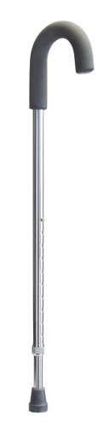6221A

Soft Grip Cane
Item# 6221A
Product Detail
• Contoured handle is designed to provide a comfortable, secure handhold.
• Attractive aluminum finish resists marring and scratching.
• Easy push-button height adjustment with locking collet for added security.
• Height adjusts from 30" to 39" in 1" increments.
• Available with a choice of grips, either durable vinyl or soft foam, and a choice of colors shown below.
• Includes laminated color operating instructions.
• Designed to meet the requirements of HCPCS code: E0100.
• 250 lb maximum weight capacity.
• Limited lifetime warranty.

